Record-Efficiency Inverted CsPbI₃ Perovskite Solar Cells
Enabled by Rearrangement and Hydrophilic Modification of SAMs

Dongfang Xu,^{[a]} Meizi Wu,^{[a]} Yimin Bai,^{[a]} Baihui Wang,^{[a]} Hui Zhou,^{[a]} Zihao Fan,^{[a]} Na Zhang,^{[a]} Jieke Tan,^{[a]} Hongxiang Li,^{[b]} Hongtao Bian^{[a]*}and Zhike Liu^{[a]*}

D. Xu, M. Wu, Y. Bai, B. Wang, H. Zhou, Z. Fan, N. Zhang, J. Tan, Prof. H. Bian, Prof. Z. Liu
[a] Key Laboratory of Applied Surface and Colloid Chemistry, Ministry of Education, Shaanxi Key Laboratory for Advanced Energy Devices, Shaanxi Engineering Lab for Advanced Energy Technology School of Materials Science and Engineering, Shaanxi Normal University, Xi’an, 710119, China
E-mail: zhike2015@snnu.edu.cn htbian@snnu.edu.cn
H. Li
[b] College of Polymer Science and Engineering State Key Laboratory of Polymer Materials Engineering, Sichuan University, Chengdu, 610065, China

Figures:
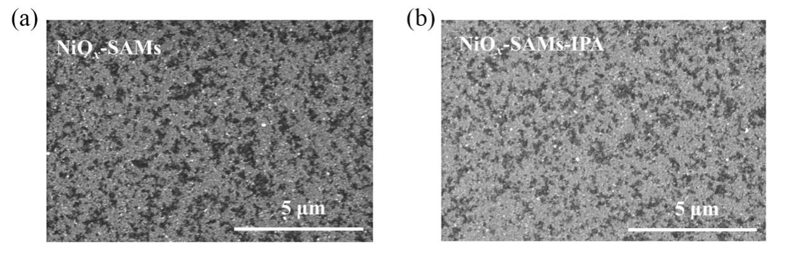
Figure S1. Top-view SEM images of Glass/ITO/NiO_{x}/SAMs a) before and b) after IPA washing.

Figure S2. The elemental map and P distribution map of the a) Glass/ITO/NiO_{x}/SAMs and c) Glass/ITO/NiO_{x}/SAMs/NCL. Distribution of elemental contents for b) Glass/ITO/NiO_{x}/SAMs and d) Glass/ITO/NiO_{x}/SAMs/NCL.

Figure S3. GIXRD spectra of a) the control and b) the NCL-treated CsPbI₃ films at different slant angles.

Figure S4. a) The steady-state PL spectra and b) TRPL curves of CsPbI₃ films on different concentrations of NCL treated glass substrate.

Figure S5. FTIR spectra of SAMs films on the Glass/NiO_{x} substrates with and without NCL treatment.

Figure S6. SFG spectra for the Glass/NiO_{x}/SAMs films with different concentrations of NCL treatment.

Figure S7. FTIR spectra for the 2PACz, 2PACz + NCL, MeO-2PACz and MeO-2PACz + NCL films.

Figure S8. a) The FTIR spectra for 2PACz and 2PACz + NCL films, b) MeO-2PACz and MeO-2PACz + NCL films;

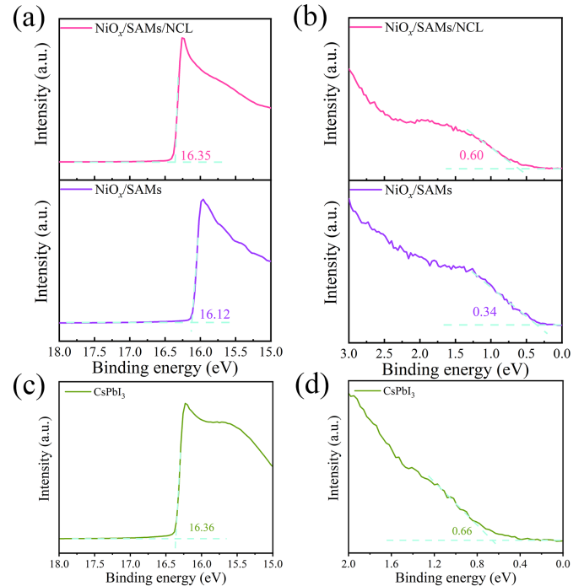
Figure S9. a) Valence band edges and b) cutoff regions of UPS spectra for the NiO_{x}/SAMs and NiO_{x}/SAMs/NCL films. c) Valence band edges and d) cutoff regions of UPS spectra for inverted CsPbI₃ films.

Figure S10. J-V curves of the inverted CsPbI₃ PSCs modified with different concentrations of NCL.

Figure S11. Current versus voltage curves for the control and target inverted CsPbI₃ devices tested in the dark.

Figure S12. Box charts of a) V_{OC}, b) FF, c) J_{SC}, d) PCE, of the PSCs (40 samples) without and with NCL treatment.

Tables
Table S1. Fitting parameters of the TRPL curves for the Glass/NiO_{x}/SAMs/CsPbI₃ films with different concentrations of NCL treatment.
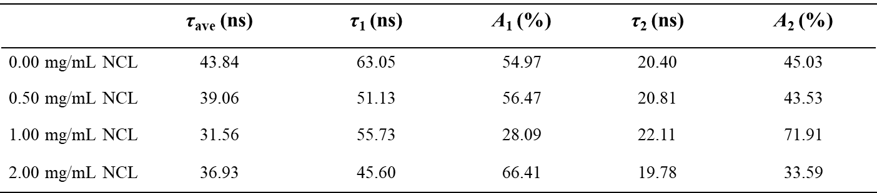

Table S2. Fitting parameters of the TRPL curves for the Glass/CsPbI₃ films with different concentrations of NCL treatment.
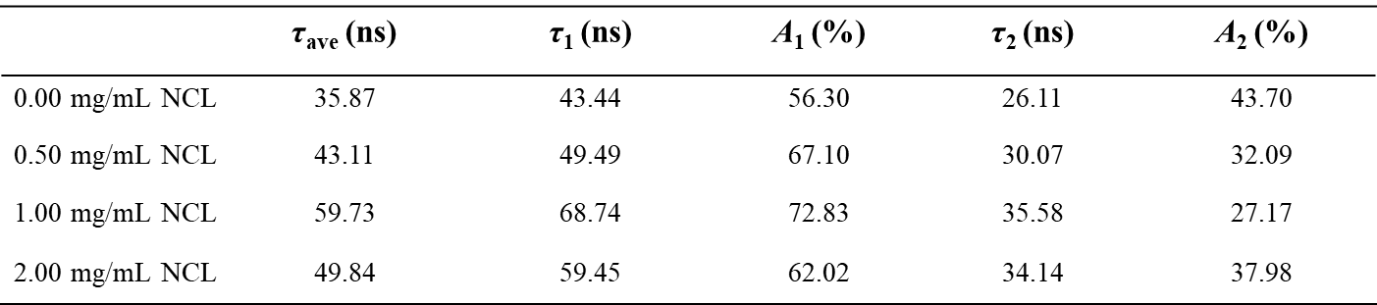

Table S3. The band structure parameters of NiO_{x}/SAMs, NiO_{x}/SAMs/NCL and CsPbI₃ films, respectively.

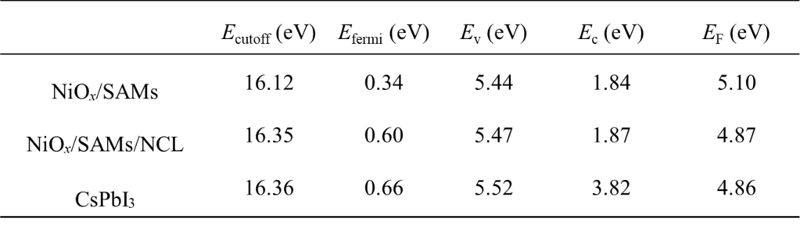

Table S4. The photovoltaic parameters of the inverted CsPbI₃ PSCs with different concentrations of NCL treatment.
.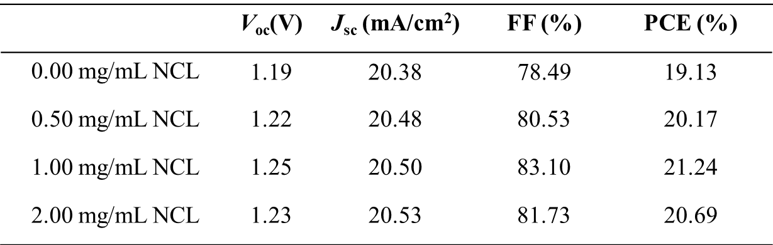

Table S5 The summarized photovoltaic performance of inverted all inorganic PSCs.

Perovskite | PCE (%) | V_{oc} (V) | E_{g} (eV) | V_{loss} (V) | Ref
CsPbI_{3-x}Br_{x} | 11.18 | 0.89 | 1.73 | 0.84 | [1]
CsPbI₃ | 13.21 | 0.95 | 1.70 | 0.75 | [2]
CsPbI_{3-x}Br_{x} | 15.45 | 1.02 | 1.73 | 0.71 | [3]
CsPbI₃ | 16.67 | 1.07 | 1.70 | 0.63 | [4]
CsPbI₃ | 18.21 | 1.10 | 1.70 | 0.60 | [5]
CsPbI₃ | 18.41 | 1.11 | 1.70 | 0.59 | [6]
CsPbI₃ | 18.93 | 1.17 | 1.70 | 0.53 | [7]
CsPbI₃ | 19.01 | 1.17 | 1.70 | 0.53 | [8]
CsPbI₃ | 19.23 | 1.16 | 1.70 | 0.54 | [9]
CsPbI₃ | 19.25 | 1.16 | 1.70 | 0.54 | [10]
CsPbI₃ | 19.27 | 1.22 | 1.70 | 0.48 | [11]
CsPbI_{2.85}Br_{0.15} | 19.34 | 1.19 | 1.73 | 0.54 | [12]
CsPbI₃ | 19.84 | 1.21 | 1.70 | 0.49 | [13]
CsPbI₃ | 20.02 | 1.19 | 1.70 | 0.51 | [14]
CsPbI₃ | 20.17 | 1.21 | 1.70 | 0.49 | [15]
CsPbI₃ | 20.17 | 1.15 | 1.70 | 0.55 | [16]
CsPbI₃ | 20.18 | 1.21 | 1.70 | 0.49 | [17]
CsPbI₃ | 20.22 | 1.19 | 1.70 | 0.51 | [18]
CsPbI₃ | 20.38 | 1.22 | 1.70 | 0.48 | [19]
CsPbI₃ | 20.38 | 1.20 | 1.70 | 0.50 | [20]
CsPbI₃ | 20.60 | 1.21 | 1.70 | 0.49 | [21]
CsPbI_{2.85}Br_{0.15} | 20.80 | 1.24 | 1.73 | 0.49 | [22]
CsPbI_{2.85}Br_{0.15} | 21.00 | 1.22 | 1.73 | 0.51 | [23]
CsPbI₃ | 21.08 | 1.20 | 1.70 | 0.50 | [24]
CsPbI₃ | 21.24 | 1.25 | 1.70 | 0.45 | This work

References:
[1] K. Shi, F. Zhang, M. Zhang, C. Chen, W. Zhang, J. Huang, Semiconductor Science and Technology 2022, 37.
[2] K. Wang, Z. Su, Y. Chen, H. Qi, T. Wang, H. Wang, Y. Zhang, L. Cao, Q. Ye, F. Huang, Y. Tong, H. Wang, Journal of Materials Science & Technology 2022, 114, 165.
[3] T. Li, W. Li, K. Wang, L. Cao, Y. Chen, H. Wang, M. Fu, Y. Tong, ACS Applied Materials & Interfaces 2023, 15, 51350.
[4] S. Fu, L. Wan, W. Zhang, X. Li, W. Song, J. Fang, ACS Energy Letters 2020, 5, 3314.
[5] Z. Xu, N. Liu, X. Liu, W. Han, W. Xu, J. Zhang, L. Huang, Z. Hu, Y. Zhu, Chemical Engineering Journal 2023, 451.
[6] N. Liu, Z. Xu, Y. Pan, J. Wang, Z. Liu, J. Zhang, L. Huang, Z. Hu, Y. Zhu, X. Liu, Chemical Communications 2023, 59, 8452.
[7] S. Fu, W. Zhang, X. Li, J. Guan, W. Song, J. Fang, ACS Energy Letters 2021, 6, 3661.
[8] C. Lu, X. Li, X. Guo, S. Fu, W. Zhang, H. Yuan, J. Fang, Chemical Engineering Journal 2023, 452.
[9] M. Yang, K. Mo, X. Zhu, Y. Liu, N. Yan, Z. Wang, Small 2024, 202310749.
[10] S. Fu, X. Li, J. Wan, W. Zhang, W. Song, J. Fang, Advanced Functional Materials 2021, 32, 2111116.
[11] S. Fu, N. Sun, J. Le, W. Zhang, R. Miao, W. Zhang, Y. Kuang, W. Song, J. Fang, ACS Applied Materials & Interfaces 2022, 14, 30937.
[12] H. Sun, S. Wang, S. Qi, P. Wang, R. Li, B. Shi, Q. Zhang, Q. Huang, S. Xu, Y. Zhao, X. Zhang, Advanced Functional Materials 2023, 33, 2213913.
[13] S. Fu, J. Le, X. Guo, N. Sun, W. Zhang, W. Song, J. Fang, Advanced Materials 2022, 34, 202205066.
[14] N. Liu, Z. Liu, J. Wang, Q. Ye, Y. Wang, W. Han, W. Xu, J. Zhang, L. Huang, Z. Hu, Y. Zhu, X. Liu, Chemical Engineering Journal 2024, 485.
[15] N. Sun, S. Fu, Y. Li, L. Chen, J. Chung, M. M. Saeed, K. Dolia, A. Rahimi, C. Li, Z. Song, Y. Yan, Advanced Functional Materials 2023, 34, 202309894.
[16] S. Wang, M.-H. Li, Y. Zhang, Y. Jiang, L. Xu, F. Wang, J.-S. Hu, Energy & Environmental Science 2023, 16, 2572.
[17] X. Guo, C. Lu, W. Zhang, H. Yuan, H. Yang, A. Liu, Z. Cui, W. Li, Y. Hu, X. Li, J. Fang, ACS Energy Letters 2024, 9, 329.
[18] C. Lu, X. Li, H. Yuan, W. Zhang, X. Guo, A. Liu, H. Yang, W. Li, Z. Cui, Y. Hu, J. Fang, Chemical Engineering Journal 2024, 480.
[19] S. Wang, P. Wang, B. Shi, C. Sun, H. Sun, S. Qi, Q. Huang, S. Xu, Y. Zhao, X. Zhang, Advanced Materials 2023, 35, 202300581.
[20] C. Lu, X. Guo, W. Zhang, H. Yuan, A. Liu, H. Yang, W. Li, Z. Cui, Y. Hu, X. Li, J. Fang, Advanced Functional Materials 2024, 202403563.
[21] T. Xu, W. Xiang, J. Yang, D. J. Kubicki, W. Tress, T. Chen, Z. Fang, Y. Liu, S. Liu, Advanced Materials 2023, 35, 202303346.
[22] S. Wang, S. Qi, H. Sun, P. Wang, Y. Zhao, X. Zhang, Angewandte Chemie International Edition 2024, 63, e202400018.
[23] T. Xu, W. Xiang, X. Ru, Z. Wang, Y. Liu, N. Li, H. Xu, S. Liu, Advanced Materials 2024, 36, 2312237.
[24] T. Li, W. Li, K. Wang, Y. Tong, H. Wang, Y. Chen, H. Qi, Z. Kang, H. Wang, Angewandte Chemie International Edition 2024, e202407508.

